# OGG同步 MYSQL TO MYSQL

## .环境准备：

source端：  
操作系统版本：Centos6.4  
hostname: mysql04

数据库版本：mysql-5.6.38-linux-glibc2.12-x86_64.tar.gz

ogg版本：122022_ggs_Linux_x64_MySQL_64bit.zip   
数据库名：test

IP:192.168.40.14  
  
target端：

操作系统版本：Centos6.4  
hostname :mysql05

数据库版本：mysql-5.6.38-linux-glibc2.12-x86_64.tar.gz

ogg版本：122022_ggs_Linux_x64_MySQL_64bit.zip  
数据库名：test

IP:192.168.40.15

## 2.安装OGG软件(source和target同样操作)

[root@mysql04 /]# cd /

[root@mysql04 /]# mkdir ogg

[root@mysql04 /]# cd /ogg/

拷贝软件

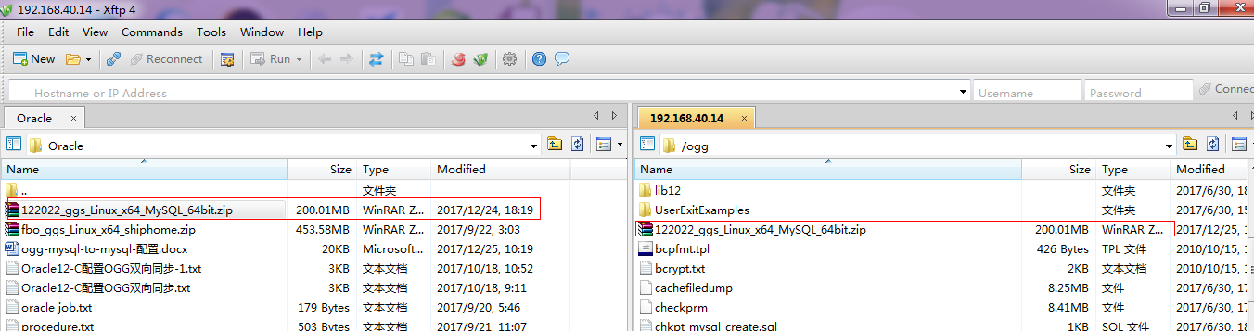

执行解压

[root@mysql04 ogg]# unzip 122022_ggs_Linux_x64_MySQL_64bit.zip

[root@mysql04 ogg]# tar -xvf ggs_Linux_x64_MySQL_64bit.tar

[root@mysql04 ogg]# ll

总用量 1534556

-rw-r--r-- 1 root root 209720688 12月 25 17:45 122022_ggs_Linux_x64_MySQL_64bit.zip

-rw-r----- 1 94110 42424 426 10月 15 2010 bcpfmt.tpl

-rw-r----- 1 94110 42424 1725 10月 15 2010 bcrypt.txt

-rwxrwxr-x 1 94110 42424 8645888 6月 30 22:27 cachefiledump

-rwxrwxr-x 1 94110 42424 8822475 6月 30 22:26 checkprm

-rw-rw-r-- 1 94110 42424 1040 6月 30 23:33 chkpt_mysql_create.sql

-rwxr-x--- 1 94110 42424 9655320 6月 30 22:21 convchk

-rwxrwxr-x 1 94110 42424 15121730 6月 30 22:23 convprm

-rw-r----- 1 94110 42424 159 10月 15 2010 db2cntl.tpl

-rwxr-x--- 1 94110 42424 19617388 6月 30 22:33 defgen

-rw-rw-r-- 1 94110 42424 557 6月 30 23:33 demo_mysql_create.sql

-rw-rw-r-- 1 94110 42424 455 6月 30 23:33 demo_mysql_insert.sql

-rw-rw-r-- 1 94110 42424 209 6月 30 23:33 demo_mysql_load.sql

-rw-rw-r-- 1 94110 42424 1691 6月 30 23:33 demo_mysql_misc.sql

drwxr-x--- 2 root root 4096 12月 25 23:49 dirchk

drwxr-x--- 2 root root 4096 12月 25 17:50 dircrd

drwxr-x--- 2 root root 4096 12月 26 00:35 dirdat

drwxr-x--- 2 root root 4096 12月 25 17:50 dirdef

drwxr-x--- 2 root root 4096 12月 26 00:35 dirdmp

drwxr-x--- 2 94110 42424 4096 6月 30 20:18 dirout

drwxr-x--- 2 root root 4096 12月 26 00:47 dirpcs

drwxr-x--- 2 root root 4096 12月 26 00:34 dirprm

drwxr-x--- 2 root root 4096 12月 26 00:36 dirrpt

drwxr-x--- 2 root root 4096 12月 25 17:50 dirsql

.......

Mysql配置

[root@mysql04 ogg]# cd /usr/local/mysql

[root@mysql04 mysql]# vim my.cnf

[mysqld]

character-set-server = utf8

collation-server = utf8_unicode_ci

init_connect = 'SET collation_connection = utf8_unicode_ci; SET NAMES utf8;'

skip-character-set-client-handshake

max_allowed_packet = 32M

lower_case_table_names = 1

log-bin=/usr/local/mysql/data/mysql-bin

max_binlog_size=4096

binlog_format=row

socket=/usr/local/mysql/data/mysql.sock

[client]

socket=/usr/local/mysql/data/mysql.sock

sql_mode=NO_ENGINE_SUBSTITUTION,STRICT_TRANS_TABLES

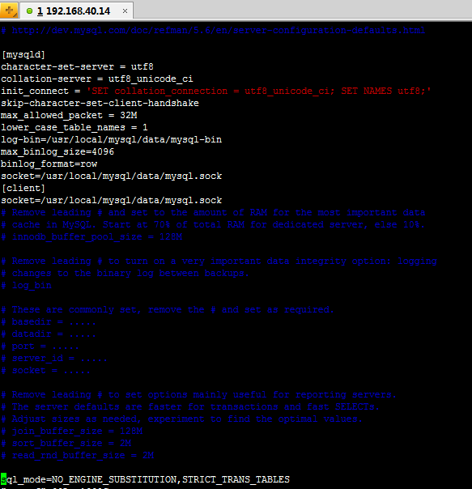

重启MYSQL服务

[root@mysql04 mysql]# service mysqld stop

Shutting down MySQL.. [确定]

[root@mysql04 mysql]# service mysqld start

Starting MySQL.. [确定]

[root@mysql04 mysql]#

初始化ogg目录

[root@mysql04 mysql]# cd /ogg/

[root@mysql04 ogg]# ./ggsci

GGSCI (mysql04) 2> create subdirs

Creating subdirectories under current directory /ogg

Parameter files /ogg/dirprm: already exists

Report files /ogg/dirrpt: already exists

Checkpoint files /ogg/dirchk: already exists

Process status files /ogg/dirpcs: already exists

SQL script files /ogg/dirsql: already exists

Database definitions files /ogg/dirdef: already exists

Extract data files /ogg/dirdat: already exists

Temporary files /ogg/dirtmp: already exists

Credential store files /ogg/dircrd: already exists

Masterkey wallet files /ogg/dirwlt: already exists

Dump files /ogg/dirdmp: already exists

## 3配置

### 1)source和target同样操作

[root@mysql04 ogg]# cd /root/

[root@mysql04 ~]# vim .bash_profile

# .bash_profile

# Get the aliases and functions

if [ -f ~/.bashrc ]; then

. ~/.bashrc

fi

# User specific environment and startup programs

PATH=$PATH:$HOME/bin

export PATH

export GGHOME=/ogg

export PATH=$PATH:$GGHOME

export LD_LIBRARY_PATH=/ogg:$LD_LIBRARY_PATH

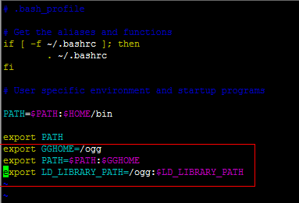

配置MGR

[root@mysql04 ~]# cd /ogg/

[root@mysql04 ogg]# ./ggsci

GGSCI (mysql04) 2> edit param mgr

port 7809

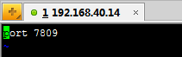

准备实验环境的mysql数据库表

[root@mysql04 ~]# cd /usr/local/mysql

[root@mysql04 mysql]# ./bin/mysql -u root -p123456

Warning: Using a password on the command line interface can be insecure.

Welcome to the MySQL monitor. Commands end with ; or \g.

Your MySQL connection id is 2

Server version: 5.6.38-log MySQL Community Server (GPL)

Copyright (c) 2000, 2017, Oracle and/or its affiliates. All rights reserved.

Oracle is a registered trademark of Oracle Corporation and/or its

affiliates. Other names may be trademarks of their respective

owners.

Type 'help;' or '\h' for help. Type '\c' to clear the current input statement.

mysql> use test;

Reading table information for completion of table and column names

You can turn off this feature to get a quicker startup with -A

Database changed

SQL> create table t3 (id int primary key, name varchar(20));

### 2)配置SOURCE端

[root@mysql04 ~]# cd /ogg/

[root@mysql04 ogg]# ./ggsci

GGSCI (mysql04) 4> dblogin sourcedb test@localhost:3306,userid root,PASSWORD 123456

Successfully logged into database.

配置抽取线程

GGSCI (mysql04 DBLOGIN as root) 5> ADD EXTRACT e1,tranlog,BEGIN NOW

GGSCI (mysql04 DBLOGIN as root) 5> ADD exttrail /ogg/dirdat/e1,EXTRACT e1

GGSCI (mysql04 DBLOGIN as root) 5> edit params e1

EXTRACT e1

setenv (MYSQL_HOME="/usr/local/mysql")

tranlogoptions altlogdest /usr/local/mysql/data/mysql-bin.index

sourcedb test@localhost:3306,userid root,PASSWORD 123456

exttrail /ogg/dirdat/e1

dynamicresolution

gettruncates

TABLE test.*;

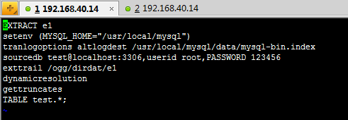

配置pup泵线程

GGSCI (mysql04 DBLOGIN as root) 7> ADD EXTRACT p1,exttrailsource /ogg/dirdat/e1

GGSCI (mysql04 DBLOGIN as root) 7> ADD rmttrail /ogg/dirdat/r1,EXTRACT p1

GGSCI (mysql04 DBLOGIN as root) 7> edit param p1

EXTRACT p1

rmthost 192.168.40.15,mgrport 7809

rmttrail /ogg/dirdat/r1

passthru

gettruncates

TABLE test.*;

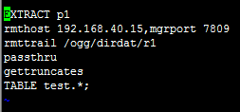

开启线程

GGSCI (mysql04 DBLOGIN as root) 8> info all

Program Status Group Lag at Chkpt Time Since Chkpt

MANAGER STOPPED

EXTRACT ABENDED E1 00:00:00 16:39:09

EXTRACT ABENDED P1 00:00:00 16:44:21

GGSCI (mysql04 DBLOGIN as root) 9> start mgr

Manager started.

GGSCI (mysql04 DBLOGIN as root) 10> start e1

Sending START request to MANAGER ...

EXTRACT E1 starting

GGSCI (mysql04 DBLOGIN as root) 11> start p1

Sending START request to MANAGER ...

EXTRACT P1 starting

GGSCI (mysql04 DBLOGIN as root) 12> info all

Program Status Group Lag at Chkpt Time Since Chkpt

MANAGER RUNNING

EXTRACT RUNNING E1 00:00:00 00:00:03

EXTRACT RUNNING P1 00:00:00 16:44:47

### **3)配置TARGET端**

[root@mysql05 ~]# cd /ogg/

[root@mysql05 ogg]# ./ggsci

Oracle GoldenGate Command Interpreter for MySQL

Version 12.2.0.2.2 OGGCORE_12.2.0.2.0_PLATFORMS_170630.0419

Linux, x64, 64bit (optimized), MySQL Enterprise on Jun 30 2017 06:32:17

Operating system character set identified as UTF-8.

Copyright (C) 1995, 2017, Oracle and/or its affiliates. All rights reserved.

GGSCI (mysql05) 2> dblogin sourcedb test@localhost:3306,userid root,PASSWORD 123456

Successfully logged into database.

GGSCI (mysql05 DBLOGIN as root) 3> ADD checkpointtable test.checkpoint

GGSCI (mysql05 DBLOGIN as root) 3> ADD replicat r1,exttrail /ogg/dirdat/r1,checkpointtable test.checkpoint

GGSCI (mysql05 DBLOGIN as root) 3> edit params r1

replicat r1

dboptions HOST localhost,connectionport 3306

targetdb test,userid root,PASSWORD 123456

assumetargetdefs

DISCARDFILE /ogg/dirrpt/r1.dsc,append,megabytes 50

MAP test.*,target test.*;

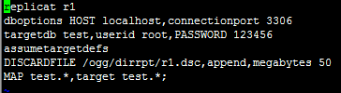

开启线程

GGSCI (mysql05 DBLOGIN as root) 8> info all

Program Status Group Lag at Chkpt Time Since Chkpt

MANAGER STOPPED

REPLICAT STOPPED R1 00:00:00 00:00:13

GGSCI (mysql05 DBLOGIN as root) 9>

GGSCI (mysql05 DBLOGIN as root) 9> start mgr

Manager started.

GGSCI (mysql05 DBLOGIN as root) 10> start r1

Sending START request to MANAGER ...

REPLICAT R1 starting

GGSCI (mysql05 DBLOGIN as root) 11> info all

Program Status Group Lag at Chkpt Time Since Chkpt

MANAGER RUNNING

REPLICAT RUNNING R1 00:00:00 00:00:03

GGSCI (mysql05 DBLOGIN as root) 12>

注：若线程开启失败（状态不是running）通过下面查看进程日志

GGSCI (mysql05 DBLOGIN as root) 12> view report r1

***********************************************************************

Oracle GoldenGate Delivery for MySQL

Version 12.2.0.2.2 OGGCORE_12.2.0.2.0_PLATFORMS_170630.0419

Linux, x64, 64bit (optimized), MySQL Enterprise on Jun 30 2017 08:22:38

Copyright (C) 1995, 2017, Oracle and/or its affiliates. All rights reserved.

Starting at 2017-12-26 06:13:14

***********************************************************************

## 4测试：

### 源端和目的端环境准备

#### A环境准备

[root@mysql04 mysql]# pwd

/usr/local/mysql

[root@mysql04 mysql]# ./bin/mysql -u root -p123456

Warning: Using a password on the command line interface can be insecure.

Welcome to the MySQL monitor. Commands end with ; or \g.

Your MySQL connection id is 5

Server version: 5.6.38-log MySQL Community Server (GPL)

Copyright (c) 2000, 2017, Oracle and/or its affiliates. All rights reserved.

Oracle is a registered trademark of Oracle Corporation and/or its

affiliates. Other names may be trademarks of their respective

owners.

Type 'help;' or '\h' for help. Type '\c' to clear the current input statement.

mysql> use test;

Reading table information for completion of table and column names

You can turn off this feature to get a quicker startup with -A

Database changed

mysql> show tables;

+----------------+

| Tables_in_test |

+----------------+

| t3 |

| tcustmer |

+----------------+

2 rows in set (0.00 sec)

mysql> select * from t3;

Empty set (0.00 sec)

mysql>

目的端环境准备

[root@mysql05 ~]# cd /usr/local/mysql

[root@mysql05 mysql]# pwd

/usr/local/mysql

[root@mysql05 mysql]# ./bin/mysql -u root -p123456

Warning: Using a password on the command line interface can be insecure.

Welcome to the MySQL monitor. Commands end with ; or \g.

Your MySQL connection id is 50

Server version: 5.6.38-log MySQL Community Server (GPL)

Copyright (c) 2000, 2017, Oracle and/or its affiliates. All rights reserved.

Oracle is a registered trademark of Oracle Corporation and/or its

affiliates. Other names may be trademarks of their respective

owners.

Type 'help;' or '\h' for help. Type '\c' to clear the current input statement.

mysql> use test;

Reading table information for completion of table and column names

You can turn off this feature to get a quicker startup with -A

Database changed

mysql> show tables;

+----------------+

| Tables_in_test |

+----------------+

| checkpoint |

| checkpoint_lox |

| t3 |

| tcustmer |

+----------------+

4 rows in set (0.00 sec)

mysql> select * from t3;

Empty set (0.00 sec)

mysql>

#### B源端数据插入

mysql> insert into t3 values(4,'mysql4');

Query OK, 1 row affected (0.01 sec)

mysql> commit;

Query OK, 0 rows affected (0.00 sec)

mysql>

#### C目的端数据检查

mysql> select * from t3;

+----+--------+

| id | name |

+----+--------+

| 4 | mysql4 |

+----+--------+

1 row in set (0.00 sec)

mysql>

mysql>

备注查看操作日志

[root@mysql04 ogg]# cd /ogg/

[root@mysql04 ogg]# tail -f ggserr.log